**AIRBNB CASE STUDY**

**METHODOLOGY DOCUMENT**

**Submitted By**

**Bharathy A**

**Neethu Santhosh Kumar**

**Sambrit Saha**

**CONTENTS**

**PROBLEM STATEMENT**

**OBJECTIVE**

**APPROACH**

**METHODOLOGY**

**RECOMMENDATIONS**

**Problem Statement**

* For the past few months, Airbnb has seen a major decline in revenue.
* Now that the restrictions have started lifting and people have started to travel more, Airbnb wants to make sure that it is fully prepared for this change.

**Objective**

 To analyze a dataset consisting of various Airbnb listings in New York.

**Approach**

* Tool used - Tableau
* Data loading
* Data cleaning
* Visualisation
* Meaningful insights from the data analysis

AB_NYC_2019 has been loaded in the tableau tool

Data cleaning

The columns last_review and reviews_per_month had null values.

last_review -change the datatype to string from date.







reviews_per_month Created a duplicated column





**Visualization**

Top Host

Earnings has been calculated by following method

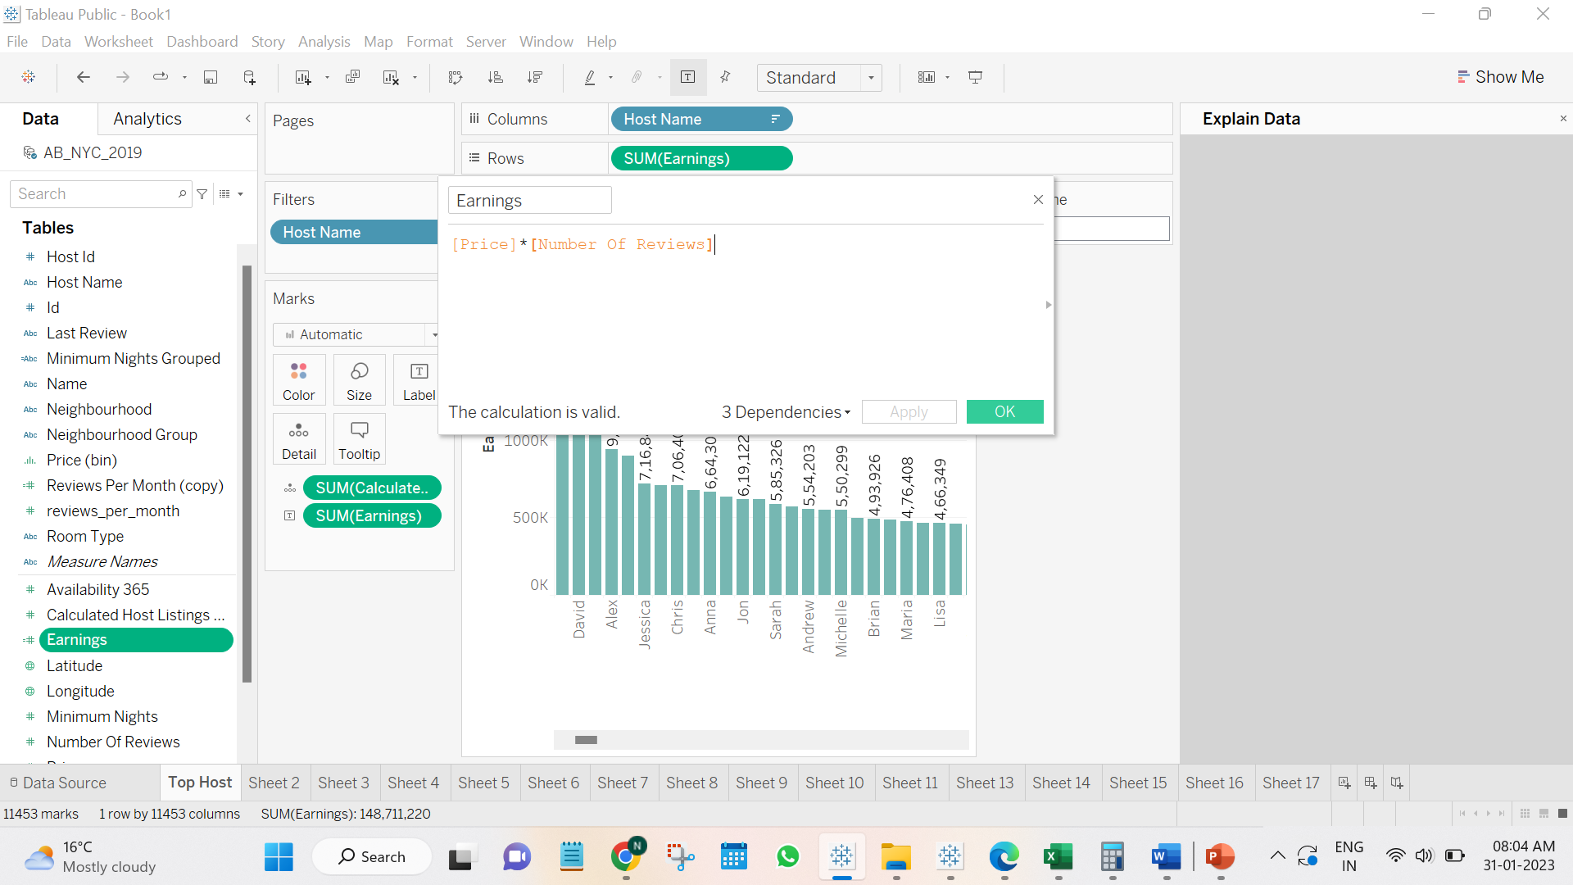

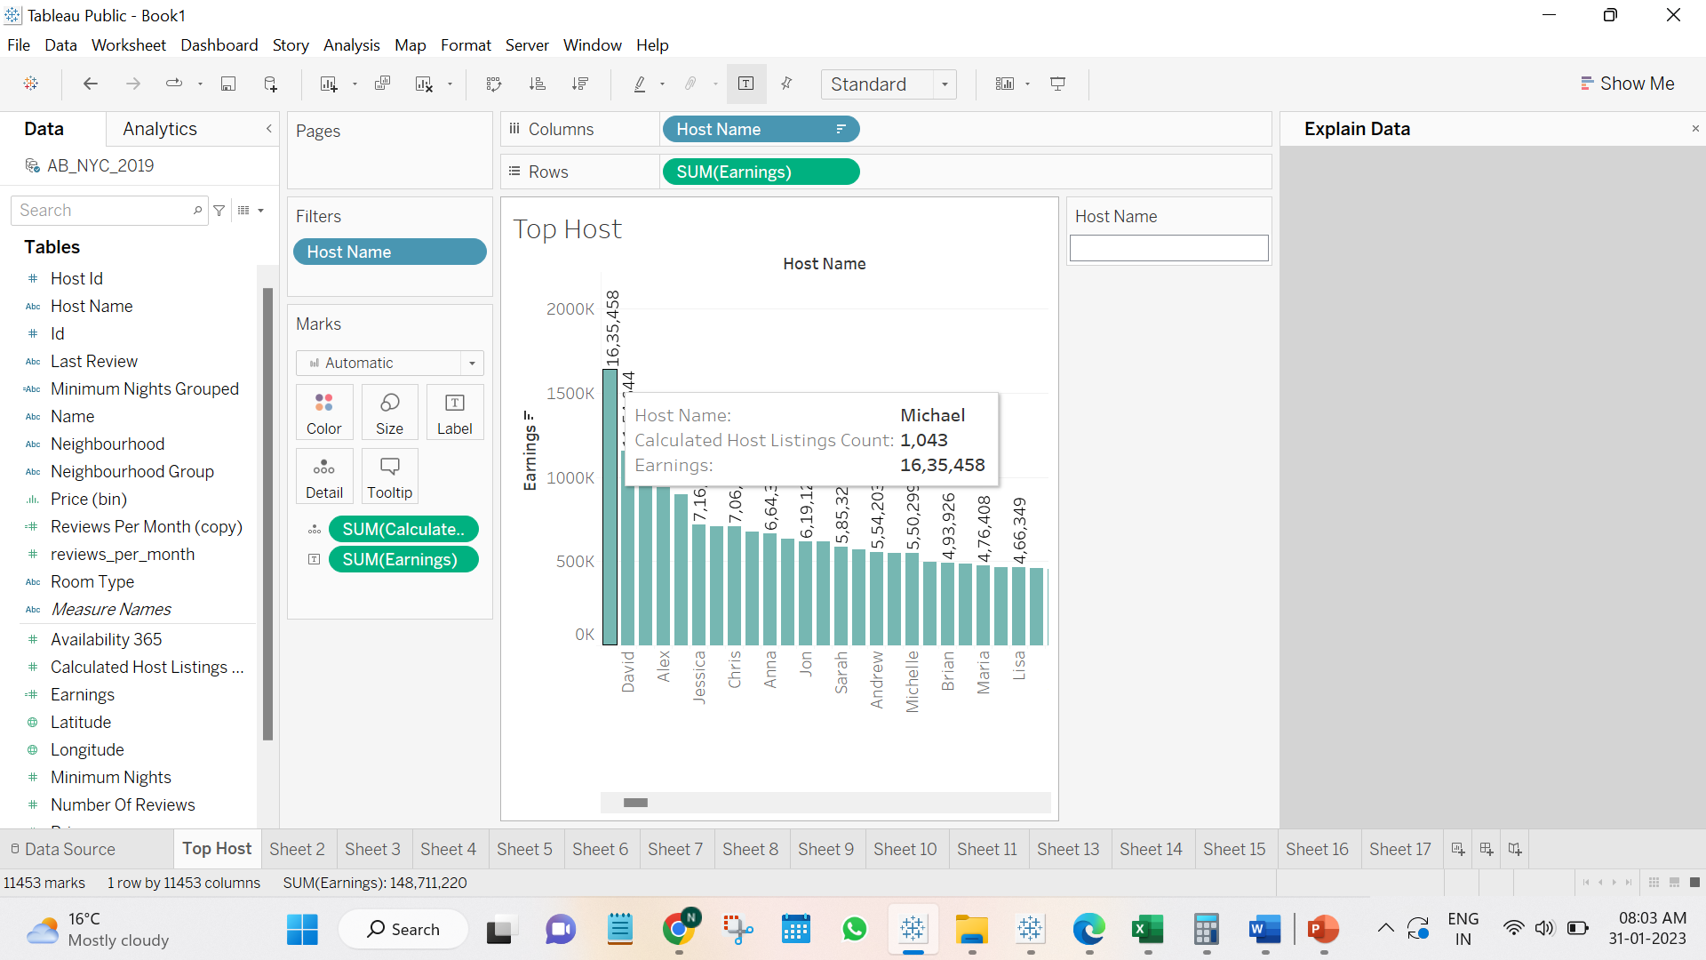

Earnings and price are inversely proportional to each other.

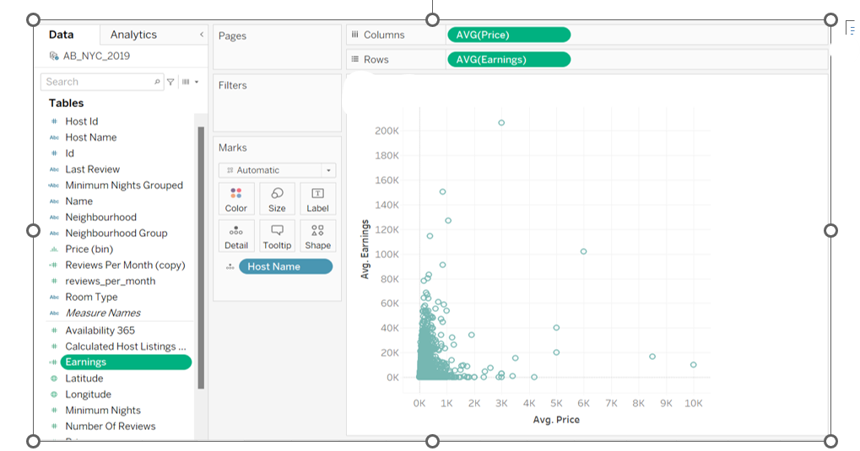

Accomodation with a view which is near to beach/lake side has the highest price.

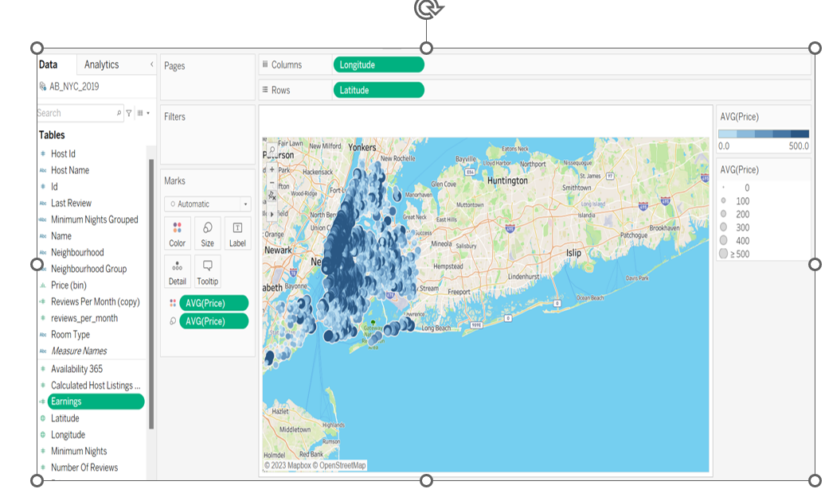

Binning for price column has been done.

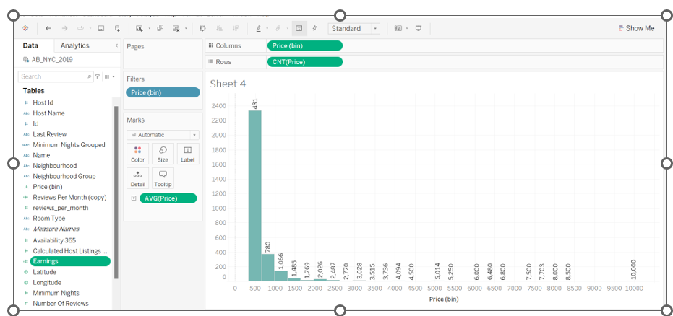

From the analysis customers prefer entire home/apartments and it is generating highest revenue when compared to private room s and shared rooms.

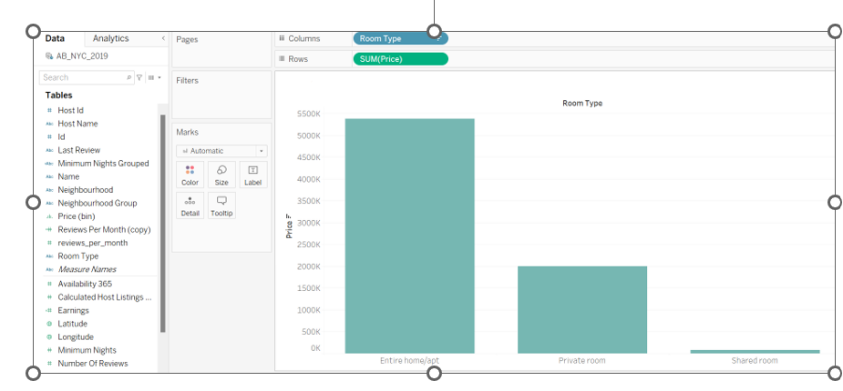

Manhattan has highest price for accommodation followed by Brooklyn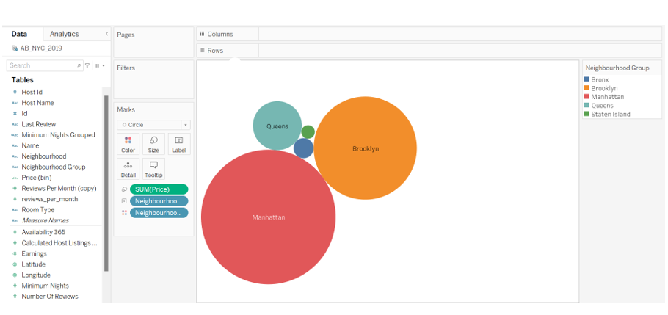

Minimum night group



When minimum night group is >31 revenue generated is the highest.

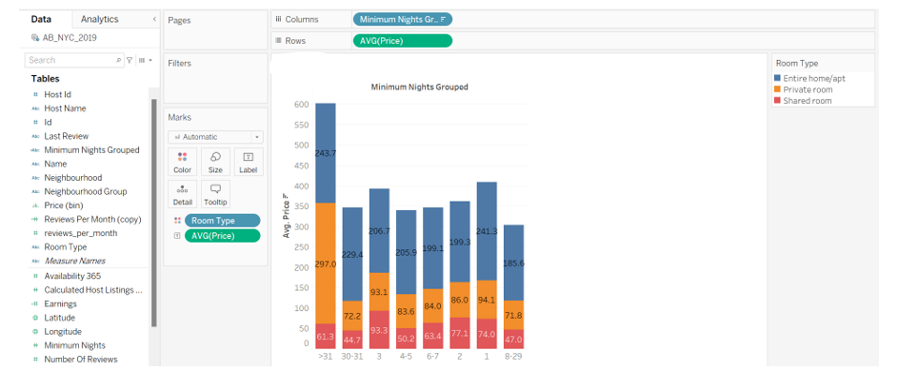

Average price for Manhattan region is the highest.

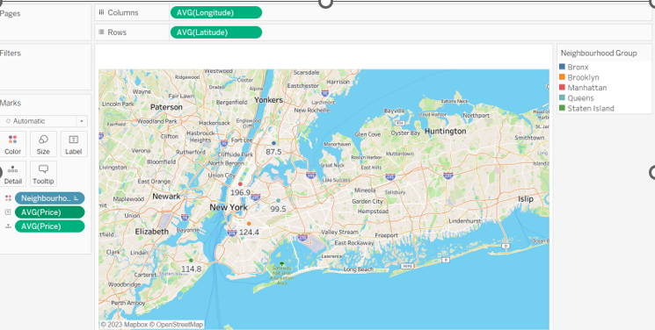

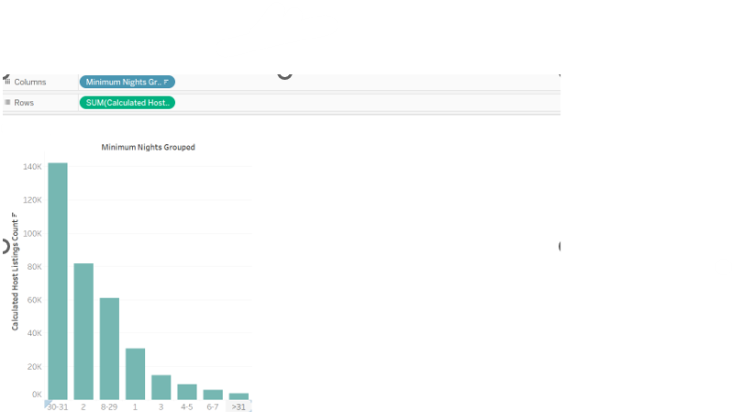

**RECOMMENDATIONS**

* Share rooms has least listing and lowest price. This opportunity could be utilized to improve the profitability.
* Manhattan has highest price for accommodation and it is affordable for upper class, reducing the price by at least 10% can attract more customers.
* Locations like Bronx can be targeted at premium rates.
* customers prefer entire home/apartments and it is generating highest revenue, so these can be targeted with non-premium price in the prime locations like Manhattan.
* Earnings and price are inversely proportional to each other so reducing the price for highest listing properties leads in generating profit.